
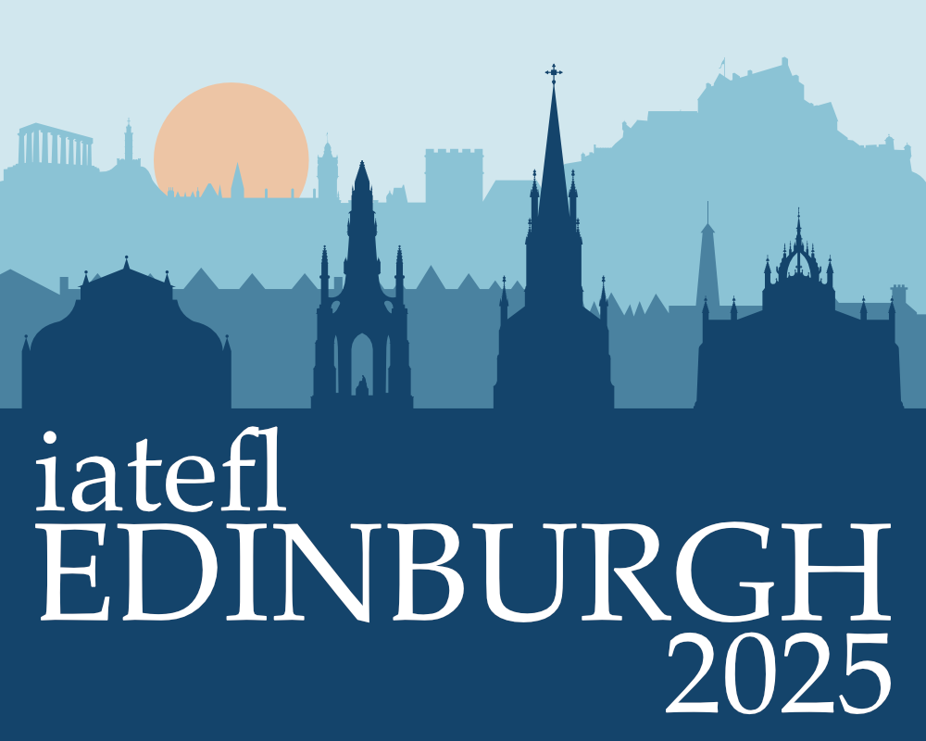

IATEFL ANNUAL CONFERENCE

8 – 11 April 2025

EICC EDINBURGH


Reservation Highway has arranged specially negotiated rates at selected hotels.

EARLY BOOKING HIGHLY RECOMMENDED PLEASE BOOK BY: Friday 7th March 2025

Bookings made after this date will be on a request basis and subject to availability, rates may vary.

Book on-line: www.reservation-highway.co.uk/efl25

Telephone our helpdesk +44 (0) 1423 525577 Email to admin@reservation-highway.co.uk

Hotel | Distance to Venue (mile) | Star  Rating | Terms | Double/Twin for sole use | Double/Twin
Kimpton Charlotte Square | 0.6 | **** | BB | £265 | £285
Intercontinental Edinburgh The George | 1.0 | **** | BB | £255 | £275
Doubletree by Hilton Edinburgh | 0.2 | **** | BB | £249 - £299 | £259 - £309
Leonardo Edinburgh Haymarket | 0.2 | **** | BB | £245 | £260
Novotel Edinburgh Centre | 0.4 | **** | BB | £195 - £225 | £205 - £235
Moxy Edinburgh Fountainbridge | 0.2 | *** | BB | £189 | £204
Voco Edinburgh | 0.1 | **** | BB | £189 | £199
Radisson Blu Edinburgh | 0.9 | **** | BB | £185 | £200
Hampton by Hilton West End Hotel | 0.5 | *** | BB | £175 - £215 | £185 - £225
Wilde Aparthotel Edinburgh Grassmarket | 0.4 | **** | BB | £172 | £179
Holiday Inn Edinburgh | 2.35 | *** | BB | £159 | £172
Point A Hotel Edinburgh | adjacent | *** | BB | £150 - £250 | £160 - £260
Staycity Aparthotel Edinburgh Westend | 0.3 | *** | RO | £145 | £145

All rates are quoted per room per night and inclusive of VAT at the prevailing rate.
Terms are BB = Bed & Breakfast RO = Room Only
Star ratings advertised by Reservation Highway follow the guidelines set out by VisitBritain and the AA.

Reservation Highway offer a full concierge service and can assist with travel advice to the event and other related services
to help you plan and enjoy your visit to Edinburgh.

RESERVATION HIGHWAY LIMITED WELLS HOUSE 8 COLD BATH ROAD
HARROGATE NORTH YORKSHIRE HG2 0NA
TEL: 01423 525577 EMAIL: admin@reservation-highway.co.uk
COMPANY REG NO: 04518087

